**Worksheet-2.4**

**Student Name**: Sahil Kaundal **UID:** 21BCS8197

**Branch**: CSE(LEET) **Section/Group:** 807/B

**Semester**: 4th **Date of Performance**: 16/04/2022

**Subject Name**: CN Lab **Subject Code:** 20CSP-257

1. **Aim/Overview of the practical:**

Create a network using Distance Vector routing Protocol using Packet Tracer.

1. **Task to be done/ Which logistics used:**

We need to send PDU from one end device to another end device with the help of router having different networks.

1. **Apparatus/Simulator used** **(For applied/experimental sciences/materials-based labs):**

Cisco Packet Tracer

1. **Algorithm/Flowchart** **(For programming-based labs):**

1. Open the simulator.

2. Plot some generic routers and some end devices (PC’s) where end devices to router is connected by Automatically Chosen wire and routers are connected each other by Serial DCE wire type.

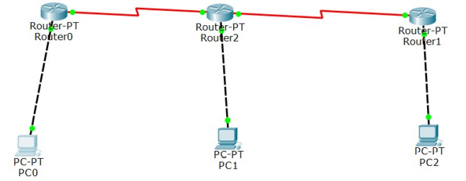

3. Give Ip addresses to all the end devices and give default Ip address to router with default gateway

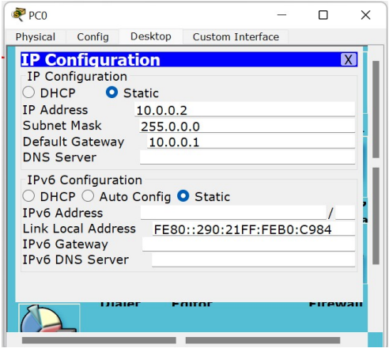

4. Now, Configure router’s fast ethernet with port status ON

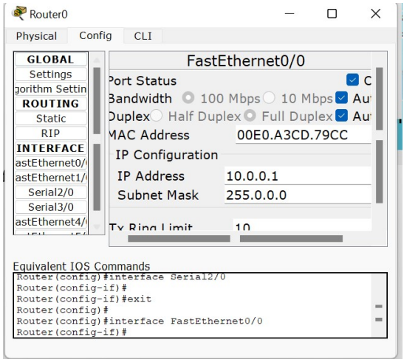

5. Now, configure router’s serial port with clock rate 64000 and port status ON

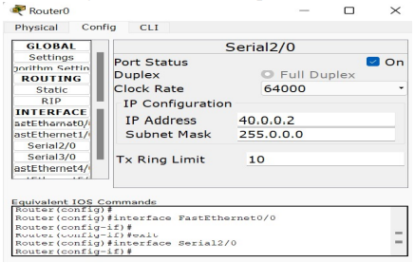

6. Now, configure static routing of router

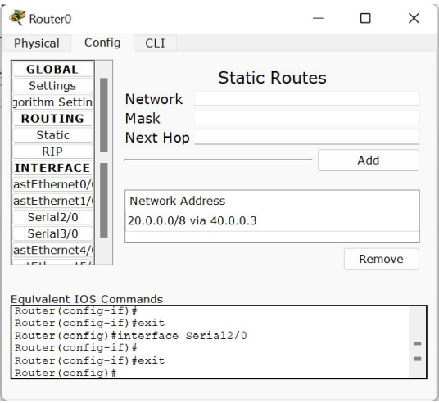

7. Also, now similarly setup other routers and end devices for perfect setup for experiment. And make sure all connections are green.

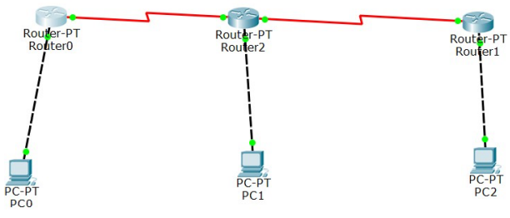

8. Now, run stimulation in real time by PDU.

9. Now, check successful status.

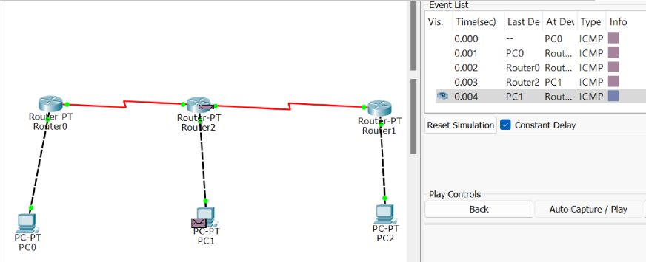

10. Now stop stimulation after successful output for experiment.

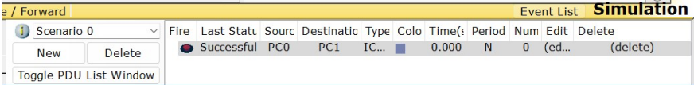

**Result: -**

I have successfully completed this experiment.

Understanded how packet travels in network if RIP is configured as routing protocol.

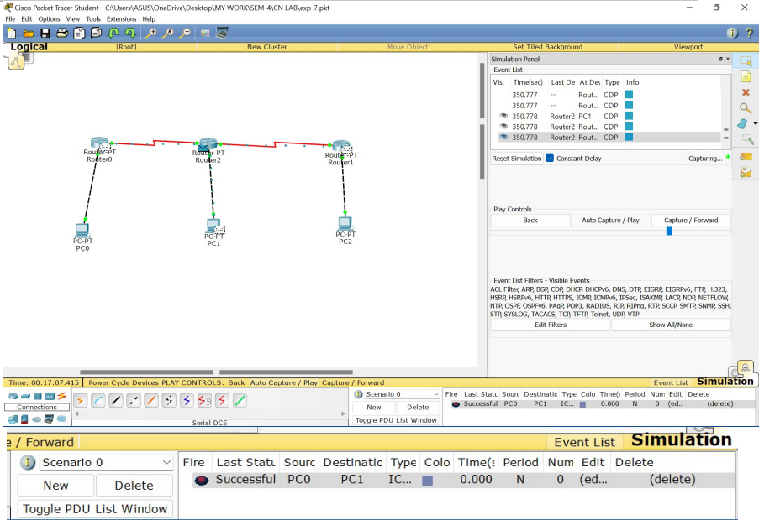

**Learning outcomes (What I have learnt):**

1. Know about how the data is transfer through computers.

2. Uses of switches (Can be used) and routers.

3. Knowledge abouts address like Ip, default, static routing, etc.

4. Some knowledge about port status, subnet mask.

5. We get to know about static and serial status.

6. We also know about clock frequency.

**Evaluation Grid (To be created as per the SOP and Assessment guidelines by the faculty):**

|  |  |  |  |
| --- | --- | --- | --- |
| Sr. No. | Parameters | Marks Obtained | Maximum Marks |
| 1. |  |  |  |
| 2. |  |  |  |
| 3. |  |  |  |
|  |  |  |  |